**Level 1: PC Tower Case**

**Outline**

Learn about the internals of a standard PC case by examining physical samples and selecting and labeling images found online. Gain deeper knowledge by researching and reporting on specific components.

**Questions**

1. Find one (or more) images that clearly show the internals of a PC Tower Case.   
   (i.e. Google images using keywords “PC Case Internals”)
2. Clearly label the following components (using arrows) on your image of the PC case internals:
   1. Motherboard
   2. Power Supply
   3. Hard Disk Drive
   4. Optical Disk Drive (e.g.DVD)
   5. USB Expansion Ports
   6. Monitor Port
   7. Audio Ports
   8. Ethernet Port
   9. Cooling Fan

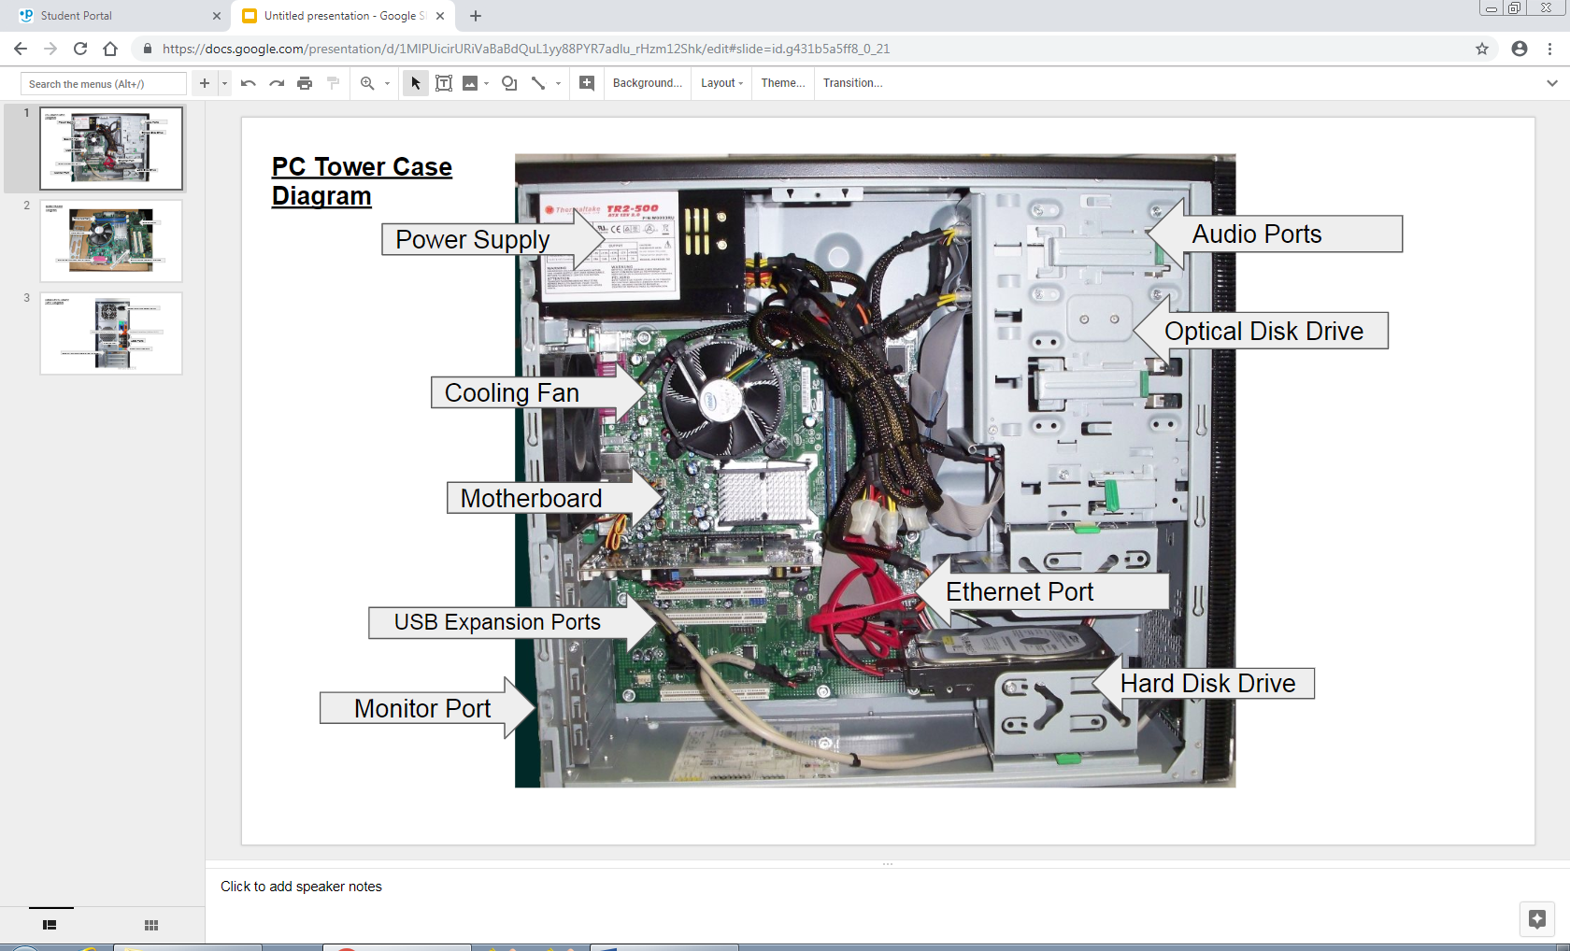

1. Research more in-depth about “Motherboards”. Make notes on the following:
   1. What different versions are currently available (speed and capacity)

* some versions are the Intel Motherboard: Z390 Aorus Pro Wi-Fi
* most common one now is ATX
  1. How the component has changed since the 1980’s
* Motherboards used to have wires and took up a lot of space
* IBM created the first motherboard it was first called a Planar which contained the CPU and RAM
* Increasing peripheral supports became a very effective cost which allowed ICs which were single circuits that allowed you to connect keyboard and more in 1990s

1. Research more in-depth about “Hard Disk Drives”. Make notes on the following:
   1. What different versions are currently available (speed and capacity)

* The Seagate 2TB 7200RPM FireCuda which has a capacity of 1- 2TB
* The Blue SSHD 4TB Review which has a speed of 150MB/s
  1. How the component has changed since the 1980’s
* IBM made the first hard drive on September 13, 1956 in held 4Mb of data and a transfer speed of 625 Kb/s
* Later version allowed a lot more storage space and allowed for 16 KB of memory

**Level 2: PC Motherboard**

**Outline**

Learn about the structure of a standard PC motherboard by examining physical samples and selecting and labeling images found online. Gain deeper knowledge by researching and reporting on specific components.

**Questions**

1. Find one (or more) images that clearly show the layout of a PC Motherboard.   
   (i.e. Google images using keywords “PC Motherboard”)
2. Clearly label the following components (using arrows) on your image of the PC motherboard:
   1. CPU (and fan)
   2. RAM Memory
   3. Disk Drive Interface (IDE or SATA)
   4. GPU Graphics Processor (either on-board or Graphics Card)
   5. Sound Processor (either on-board or Sound Card)
   6. Wi-Fi / Ethernet Network Interface (either on-board or Graphics Card)

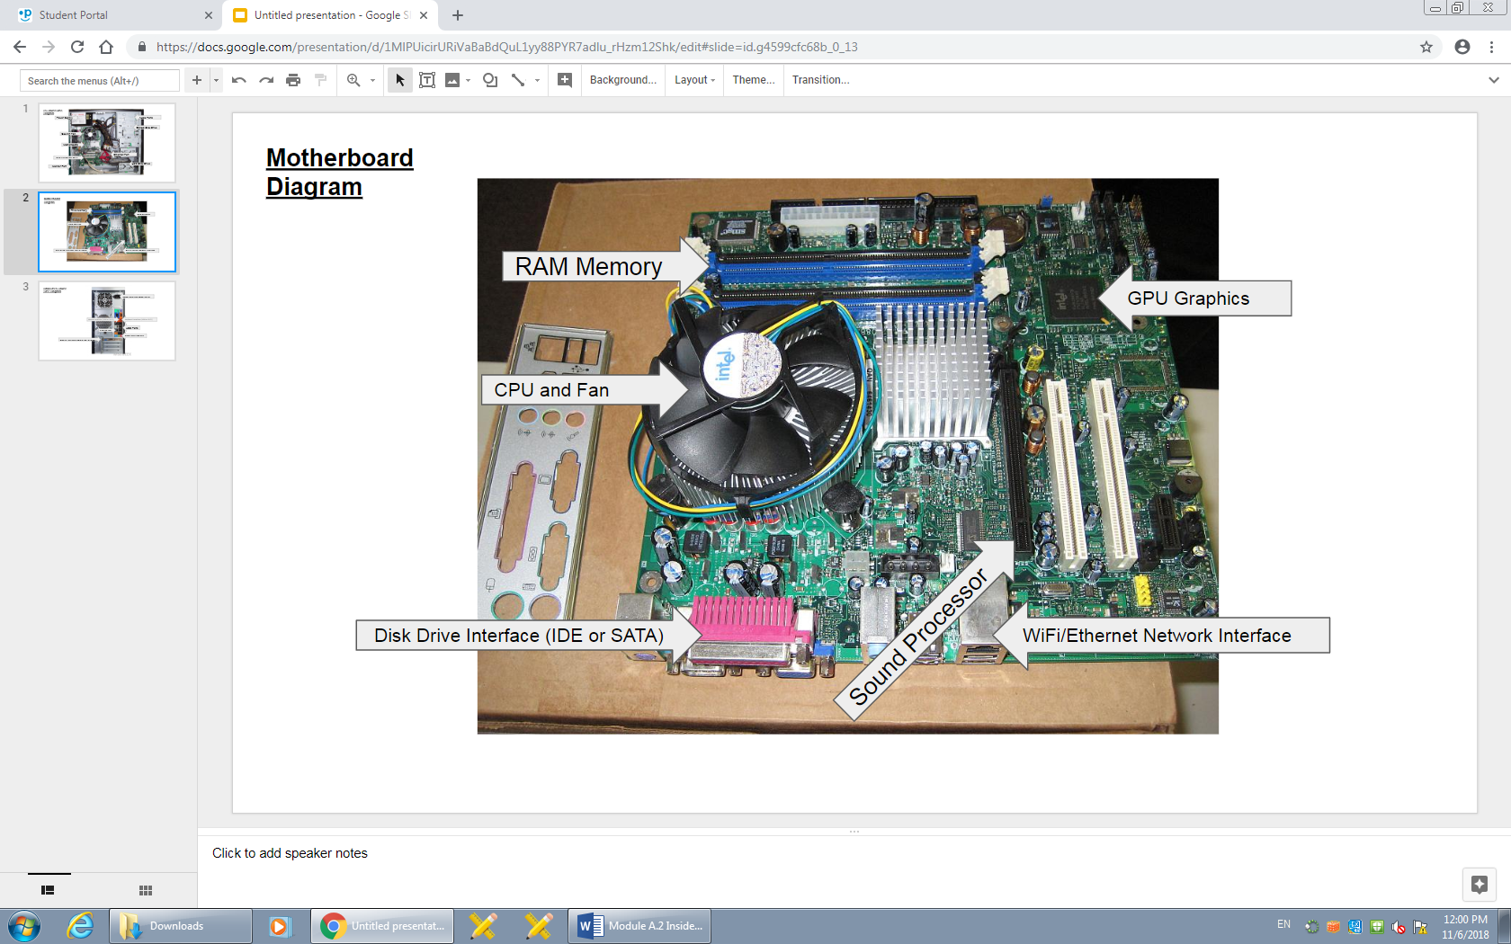

1. Research more in-depth about “CPU Processor Chip”. Make notes on the following:
   1. What different versions are currently available (speed and capacity)

* The AMD Sempron and Intel Celeron are currently available 1MB
  + The Sempron is 140 even faster than all single core Athlon microprocessors
  1. How the component has changed since the 1980’s
* First microprocessor was the four-bit 4004 built in 1971 by Intel, mostly meant to be used in calculators and other smaller components and not meant to be used in computers yet
* In 1995 the Pentium Pro was released with a clock speed of 66 MHz
* In 2000 the Pentium IV was Intel’s newest single core processor that had a clock speed between 1.3 GHz to 3.08 GHz

1. Research more in-depth about “RAM Memory”. Make notes on the following:
   1. What different versions are currently available (speed and capacity)

* The Corsair Vengeance LED has 3, 466 MHz speeds
* The G.Skill Trident Z RGB has speeds between 2, 400 MHz to 4, 266 MHz
* The newest version is DDR4 it has improved performance other than its predecessors and has lower power consumption
  1. How the component has changed since the 1980’s
* First form of RAM appeared in 1940’s where data would be stored in the form of magnetized rings and each one was wired separately meaning it was a huge installation
* A single ring would store data as zero and ones
* The change came in 1970 when solid state memory was founded and where the transistors were close enough to store a lot more information
* in 1980 Apple computers released Macintosh computers which was the first computer to come with 12 KB of memory

**Level 3: Peripheral Devices**

**Outline**

Learn about how peripheral devices are connected to the back side of a typical PC tower case. Examine physical samples, select and labeling images found on-line and gain deeper knowledge by researching and reporting on specific components.

**Questions**

1. Find one (or more) images that clearly show the layout of the back of a typical PC tower case.   
   (i.e. Google images using keywords “Back Of PC Tower”)
2. Clearly label the following components (using arrows) on your image of the back of a typical PC tower case:
   1. Power cord and power switch
   2. Monitor Interface (VGA or DVI or HDMI)
   3. Mouse Interface (USB or PS/2)
   4. Keyboard Interface (USB or PS/2)
   5. USB Ports
   6. Audio Inputs / Outputs
   7. Ethernet Interface

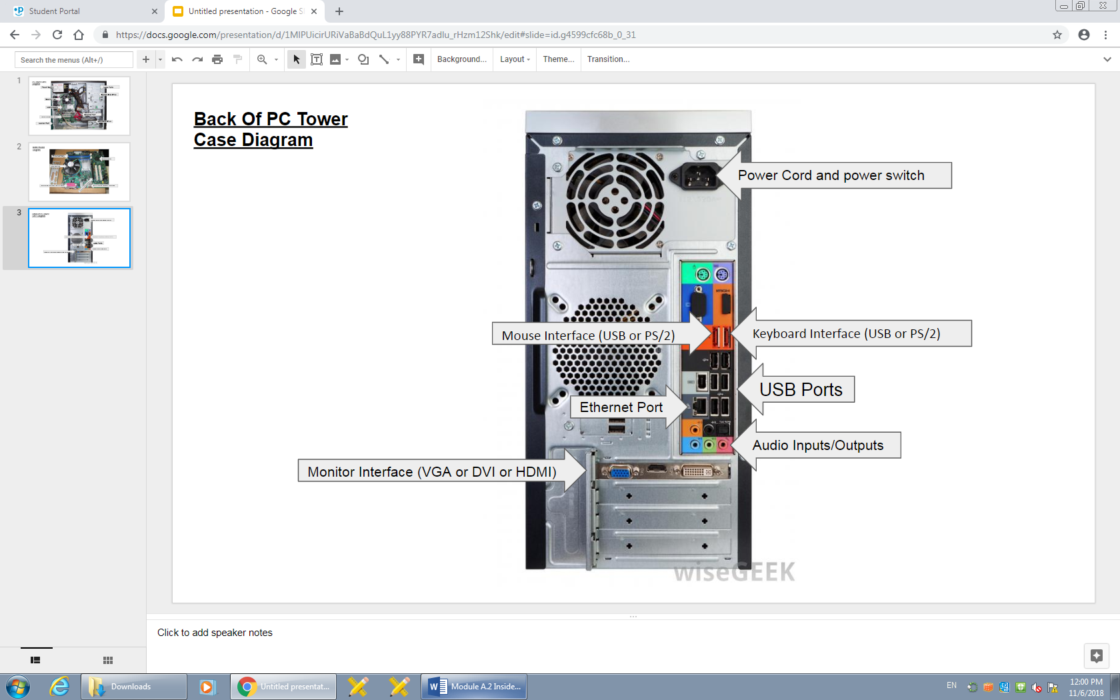

1. Research more in-depth about “Monitor Technology”. Make notes on the following:
   1. What different versions are currently available (e.g. VGA / DVI, Flat Panel Technology))

* Quantum Dot Display with wide DCI-P3 which basically means its more energy efficient than other panel types as well as having a high range of colour for realistic gaming experience (quality of movie projectors)
  1. How the component has changed since the 1980’s (e.g. Display Resolution, Technology)
* before the display technology was huge a CRT(Cathode Ray Tube which was used to display image on screens by firing electrons at them
* eventually it was replaced with LCD and LED monitor which were more thin and efficient

1. Research more in-depth about “External Portable Storage”. Make notes on the following:
   1. Floppy Disks

* a magnetic storage medium for computers
* it's a flexible floppy disk sealed in a plastic carrier
* they were used to distribute software, transfer files and create backup files for data
* it was also sometimes used to store the operating system of a computer, since hard drives were expensive
* it got smaller and smaller but then in the 1990s it got replaced by USB flash drives, hard drives and more
  1. CD-ROM / DVD / Recordable CD/DVD
* is a CD that can only be accepted by computers with optical drives and can’t be changed but can only be read
* it had a large capacity(600 MB) and with the read only option it made it perfect for retail software
  1. USB Memory Drives
* used for data storage which includes flash memory, USB (Universal Serial Bus) interface
* its removable, rewritable, small, somewhat durable
* the larger there storage space is the faster it my operate
  1. Compact Flash Memory
* is most commonly used for storing pictures in digital cameras, but are also used in Portable music players and PDAs
* originally could only store a few megabytes, but later developed to store several gigabytes
* new CF+ could store 137 GB of data
  1. Cloud Based Storage
* is computing model in which data is stored in remote servers accessed from the internet
* maintained and operated by cloud storage service provider

**Level 4: PC Component Presentation**

**Outline**

Explore the development and features of a specific PC hardware component through deeper research and investigation. Work in partners to create a short presentation. Deliver the presentation to the class.

Each group will research a unique PC hardware component . Your specific topic will be assigned from the list provided below.

**Presentation Structure**

1. Explain what the PC component does and how it fits together with other components to make up a fully functioning PC.
2. Explain how the PC component works. Provide a diagram (image) showing the main parts of the component.
3. Research the current state of the art of the component in terms speed, capacity (size), and other related factors.
4. Research on-line suppliers that sell the PC Component. List the specifications for the available products and the cost (price).
5. Research how the PC component has changed and evolved since the early days of PCs in the 1980’s. Cover each of the following topics separately:
   1. Component Speed
   2. Component Size / Capacity
   3. Two other specifications specific to the PC component (ask Mr. Nestor)

**PC Component Topics**

|  |  |  |
| --- | --- | --- |
| **Topic** | **Partner 1** | **Partner 2** |
| CPU Microprocessor Chip |  |  |
| Motherboard Layout |  |  |
| Computer Graphics |  |  |
| Sound & Audio |  |  |
| Hard Disk Drives |  |  |
| Removable Disk Storage |  |  |
| Network / Internet Connectivity |  |  |
| Mouse / Pointing Devices |  |  |
| Monitor & Display Technology | Raj | Raagaventhan |
| Printers & Output Technology |  |  |